1. In this selection, we are going to discuss another root element in OpenAPI Specification called **Component**.
2. 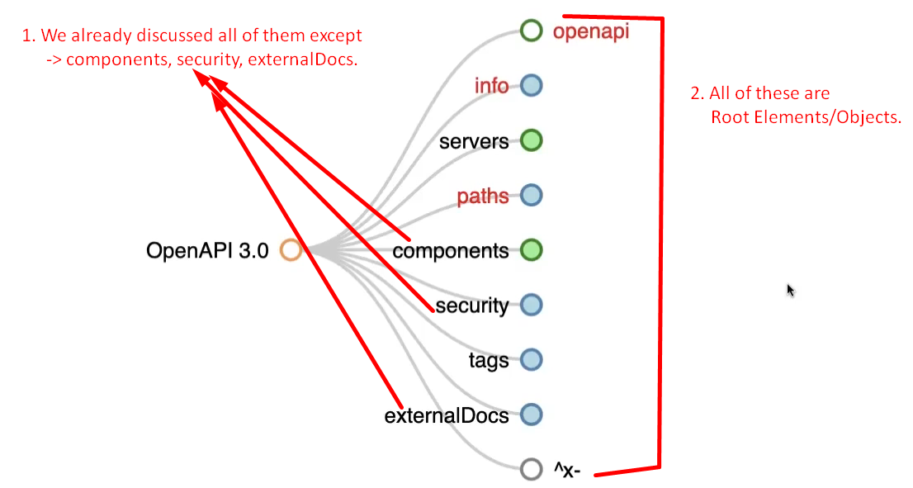
3. Let’s discuss component root element.
4. 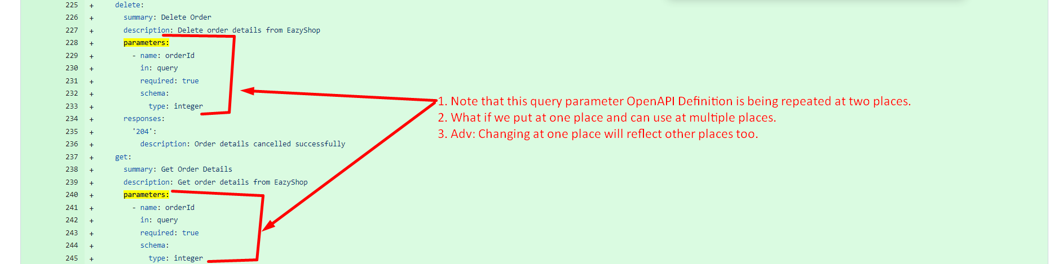  
   These duplicates can be got rid of with OpenAPI Element/Object **called components**.
5. Let us see what is components and a sample code to define component for schema.   
   